# **Sage People Technical Test for Test Automation**

## Overview

Sage people is a cloud-based people management product which supports a full employment journey. One of the aspects of the employment journeys is Performance management, using which people can create and communicate personal ‘Objectives’ clearly and monitor progress with a range of effective measures.

## Exercise - Write automated tests for creating a “New Objective” using Selenium Webdriver.

In order to access the application that you need to automate, please log into Salesforce with the login details provided in the email.

Url:  <https://login.salesforce.com/>

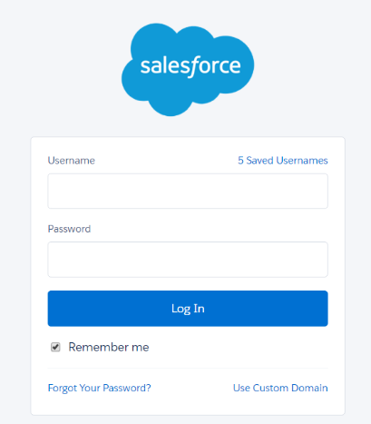

Once logged in, you would be taken to the Sage People employee portal.

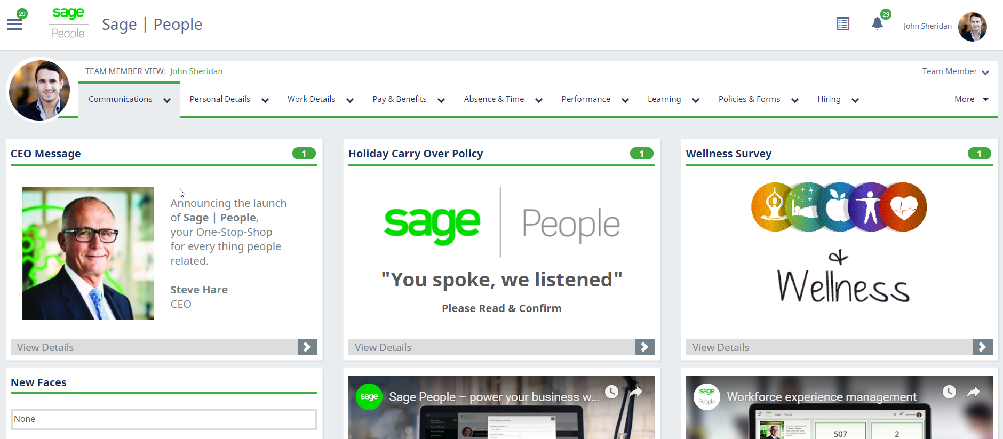

If you are still see the Salesforce UI please, use the ‘**Workforce experience**’ link to open the Sage People employee portal.

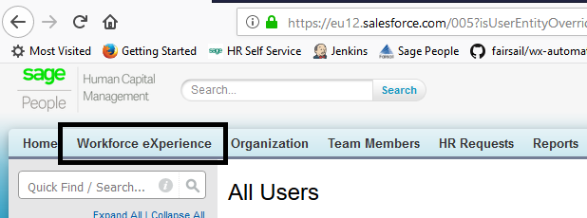

Once on the employee portal open the Navigation bar from the top left corner and Select ‘Objectives’

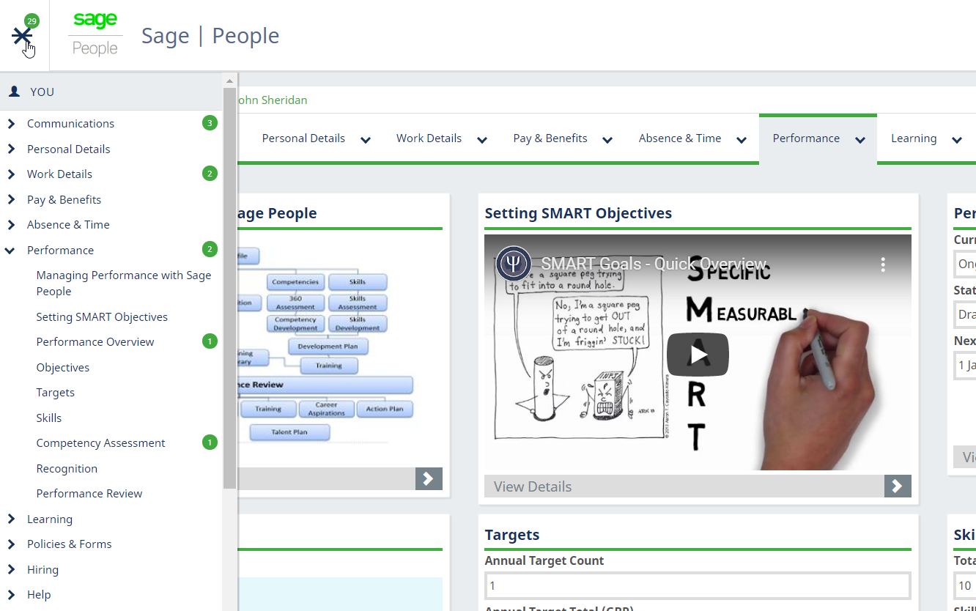

The details on how to setup Objectives from the employee portal are documented in the PDF file attached called “Sage People Objective setting guide”.

## What are we looking for

An executable automation test suite demonstrating the best practices. Be able to explain the approach taken when designing the tests.

You can either email it to us or bring it with you when you come in.